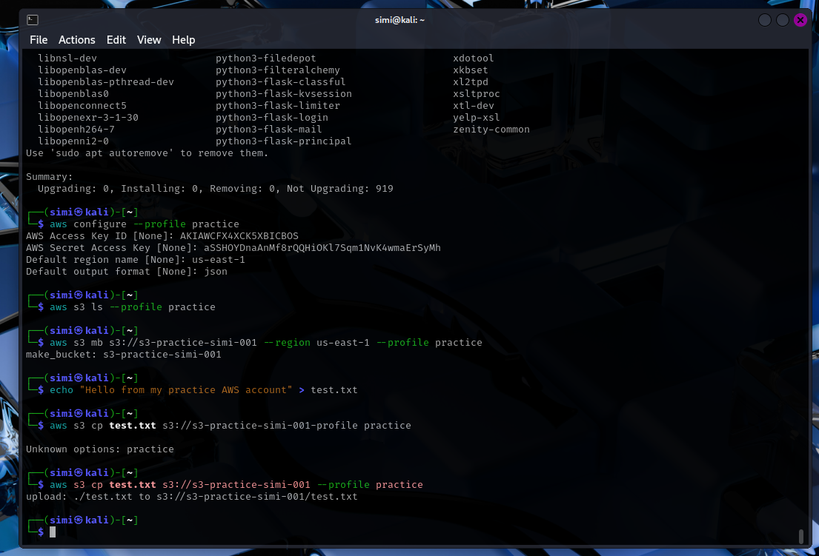

# Cloud Project 001 – S3 Bucket Creation Using AWS CLI

**Date Completed:** 6/15/2025

**Environment:** Kali Linux VM (Local)

**AWS Profile Used:** practice

**Region:** us-east-1

---

## 🎯 Objective

To create an AWS S3 bucket using the AWS CLI, upload a test file, and confirm successful configuration and access, all without using the web console.

---

## 🛠️ Tools & Skills Used

- AWS CLI (configured using Access Keys)

- Kali Linux Terminal

- S3 bucket management

- CLI-based cloud interaction

---

## 🔧 Commands Executed

```bash

# Create test file

echo "Hello from my practice AWS account!" > test.txt

# Make new S3 bucket

aws s3 mb s3://s3-practice-simi-001 --region us-east-1 --profile practice

# Upload file

aws s3 cp test.txt s3://s3-practice-simi-001 --profile practice

# Verify file exists

aws s3 ls s3://s3-practice-simi-001 --profile practice

**RERUN PRACTICE**

# Re-list files in your bucket

aws s3 ls s3://s3-practice-simi-001 --profile practice

# Upload another test file

echo "new file" > another.txt

aws s3 cp another.txt s3://s3-practice-simi-001 --profile practice

---

### 🧠 To Practice Again:

Just repeat any command using the same CLI:

- Use the same bucket name

- Upload more files

- Practice with `aws s3 rm` to delete files

- Try `aws s3 rb s3://bucket-name --force` to delete the bucket if needed